WH_A_127: How to Plan an Eco-Friendly Wedding

Say “I Do” to Green Weddings

Mention “eco-friendly” weddings to most brides and grooms, and the words “granola,” “grungy” and “hippie” probably come to mind. But the wedding industry itself is becoming more and more green-minded, making it easier and more affordable than ever to respect the environment while tying the knot.



Location
One of the earliest considerations for any wedding is the location. Near home or destination? Same site for ceremony and reception or two? Indoors or outdoors? For the bride and groom looking to minimize the carbon footprint of their big day, green thinking narrows down these choices to some extent. Depending on where the majority of your guests are traveling from, destination weddings typically require more fuel consumption – whether via car, plane, or train – than near-home affairs. Also, by minimizing the number of venues involved, such as for the ceremony and reception, you limit the amount of driving guests have to do, thus limiting fuel consumption even further. To go the extra mile, look into green hotel options (check The Green Hotels Association online) for guests and block off rooms there to encourage participation.

As far as specific venue choices, alfresco options are much more eco-friendly, as traditional spaces like ballrooms and resorts use a lot of electricity, water, and more to pull off the event. Instead, consider beaches, backyards, city parks, gardens, organic farms, local CSAs, national and state parks for their natural beauty and inherent environmentalism. [1] Planning a daytime even prevents the need for additional lighting, and most venues that accommodate weddings come equipped with modern facilities like bathrooms, so you and your guests will still be comfortable. [2] However, consider placing a notice in the bulletin or a sign at the entry sweetly reminding guests to respect their surroundings by not littering or trampling flora.
Photo source: http://inhabitat.com/green-wedding-guide-location/

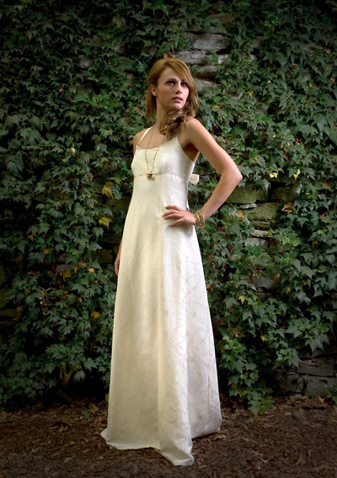

Attire
Another early decision to make is the attire, not only for the bride and groom but for the bridesmaids and groomsmen as well. It’s important to ask: Where is this garment coming from, and what will happen to it afterward? One of the simplest ways to be green minded is to reuse clothing. Whether you rent a dress or tux, buy one vintage or wear a family member’s item, this prevents the energy consumption and waste associated with creating an entirely new garment. Online options include Ebay, Encore Bridal, The Dress Market, and Brides Against Cancer, which sells once-worn and sample gowns to benefit women with breast cancer. Once the wedding is over, many brides choose to keep their gowns as a sentimental souvenir. But more and more eco-minded brides (and grooms and wedding party members) are donating their ensembles to charitable organizations such as The I Do Foundation, which donates 20 percent of the profits from the sale of each dress to a charity of one’s choice. Remaining funds support the foundation’s work to encourage charitable giving at weddings.

If you’re dead set on having a custom creation, don’t fret: You can still be eco-friendly. In fact, green fashions have become much more stylish and affordable over the past decade – so much so that guests and onlookers can’t even tell the difference. Earth-friendly fabric choices include hemp, organic cotton, linen, tencel, and silk from Conscious Clothing and Threadhead Creations. [3]
Photo source: http://www.threadheadcreations.com

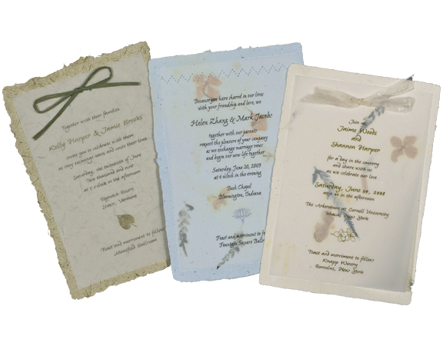

Invites
From engagement announcements and save-the-date cards to ceremony programs and thank you notes, a wedding requires a lot of paper – and that’s not even counting the wedding invitation itself, which includes multiple pieces such as RSVP cards, venue directions, event schedules, and more. Some eco-minded couples have gone so far as to use e-vites and customizable websites, via Eweddings and The Knot, to communicate with guests. But, for the more traditional among you, we know that’s asking a lot. After all, you can’t put a website in a scrap book! Yet you can still minimize your paper consumption surrounding the big day by using 100-percent recycled, partially recycled or totally tree-free papers. Some companies that offer such wares include Earthly Affair, Of the Earth, Green Field Paper Company, Invitesite, and Twisted Limb Paperworks. [4]
Photo source: http://www.twistedlimbpaper.com/panel_invitations.htm

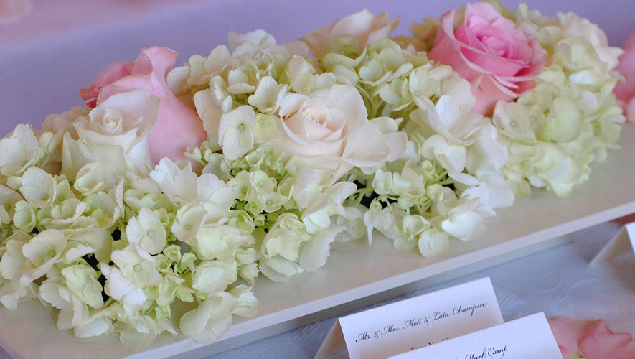

Décor
Since couples have endless options to choose from to customize their wedding décor, this is one of the easiest aspects in which to be eco-friendly. First off, flowers always make a big impact – both on the venue’s aesthetic and on the overall budget – so they should be chosen carefully. Avoid purchasing imported flowers from developing countries, which often utilize pesticides and poor labor conditions. Buying from area growers not only bolsters the local economy but also minimizes the distance your blooms have to travel – which is good for the environment, your wallet and the plants themselves. Other options include using organic flowers, growing your own, using dried or silk flowers, or reusing arrangements from the ceremony in the reception. Whatever mode you choose, make sure those blossoms find a welcome home after the big event by encouraging guests to take them home or donating them to a local hospital or senior citizen center.

Apply the green theme to centerpieces as well by using plantable perennials or baby bushes for guests to take home as gifts. Even vases made from recycled glass or sustainable materials, such as bamboo, help the eco cause – it all adds up. [5] When choosing tabletop and other décor, keep in mind how such items could be reused or recycled in the future, instead of having them collect dust in your basement or dumping them on the trash heap.
Photo source: http://www.weddingdecor.com/

Food
Like with flowers, the origins of the food you’re serving makes a big difference in your event’s carbon footprint. While serving solely organic food ensures that your foodstuffs were grown responsibly, this can be rather expensive. Instead, one of the simplest ways to think green about cuisine is to use a caterer that utilizes locally grown food. This prevents the energy costs of shipping ingredients from far-off locales and decreases the amount of refrigeration and packaging needed to keep the products fresh. [6] To prevent waste, don’t serve oversized portions; then, instead of trashing any leftovers, donate them to a local shelter. As far as serving utensils and dishware, follow this rule of thumb: It’s better to reuse items instead of buying new or disposable ones. Rely on your catering company to provide actual glasses, napkins and dishes instead or paper or plastic ones that will just get thrown away. [7]
Photo source: http://www.herecomestheguide.com/images/vendor_large/WolfgangPuckCatering1.jpg

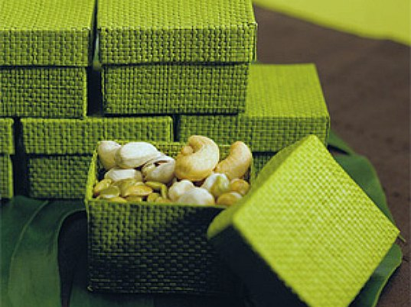

Other Considerations

- Guests: The fewer, the greener.
- Rings: Do your research and don’t buy “blood” diamonds or “dirty” gold.
- Registry: Don’t register for things you don’t need: give guests the option of donating in your name. [8]
- Favors: Most guests wind up tossing party favors. Instead, give a charitable donation or something edible. [9]
- Travel: Purchase carbon offsets at Terra Pass or Native Energy to reduce the carbon footprint of guests’ travel. [10]
Photo source:

Sources:
1. http://inhabitat.com/green-wedding-guide-location/
2. http://wedding.theknot.com/real-weddings/green-weddings/articles/eco-friendly-wedding-guide.aspx?MsdVisit=1
3. http://www.greatgreenwedding.com/attire.php
4. http://www.greatgreenwedding.com/invitations.php
5. http://www.greatgreenwedding.com/flowers.php
6. http://wedding.theknot.com/real-weddings/green-weddings/articles/eco-friendly-wedding-guide.aspx?MsdVisit=1
7. http://inhabitat.com/green-wedding-guide-location/
8. http://www.greatgreenwedding.com/default.php
9. http://wedding.theknot.com/real-weddings/green-weddings/articles/eco-friendly-wedding-guide.aspx?MsdVisit=1
10. http://inhabitat.com/green-wedding-guide-location/

